**Constructing a pushdown automaton for a given CFG**

There is a need to identify the center of the string.

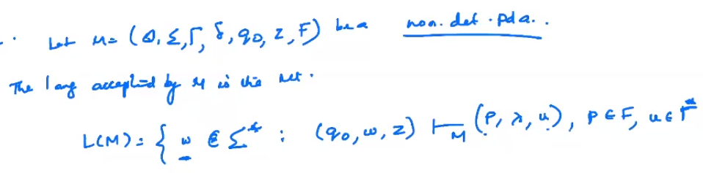

Eg

1)

Language to identify even palindromes

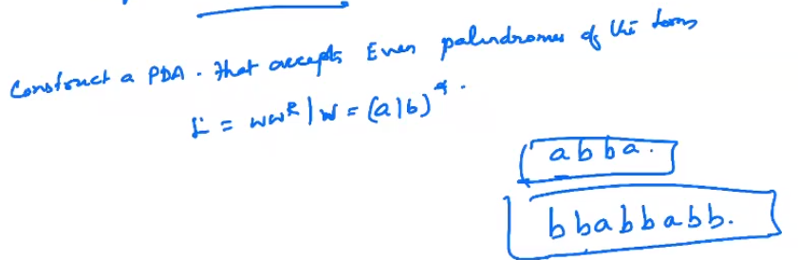

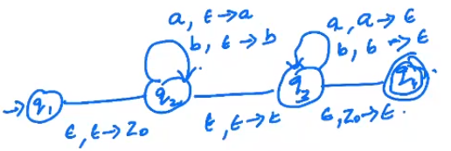

Test

String “abba”

Consider all possible transitions

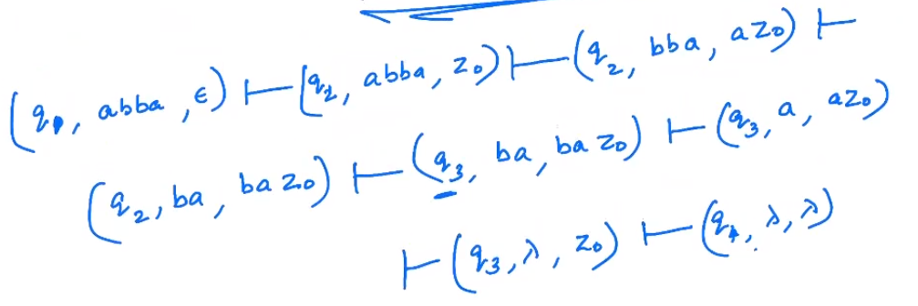

At q3, we pop b and then a. Leaving z0 at top of the stack. Then the last transition takes input epsilon and moves M into state q4, which is a final state.

Hence this string is accepted by M.

If any one of the transitions leads to a final state, then the string is said to be accepted by the automaton M.

1. No of a’s and b’s to be equal.

Consider a to be represented by 0, b by a 1. And whenever a arrives, push 0 into stack. If there is a b, pop the stack. Then at the end if the stack is empty, accept the language. Similarly, if a b arrives first, push a 1 into the stack, and pop whenever a arrives.

